Intro to Databases – Lab Report 04
Student Name: Qasim bin Mehmood
Student ID: AS25SYD006
Course: Intro to Databases
Date: June 20, 2026

Submitted to: Prof. Dinakar Bhotta

Table of Contents
1. Create Client, Database, and Collection 3
3. Insert User - Sherzod 4
4. Find User – Qasim 5
5. Update User Dinakar with Tifano 5
6. Delete User – Tifano 5

1. Create Client, Database, and Collection
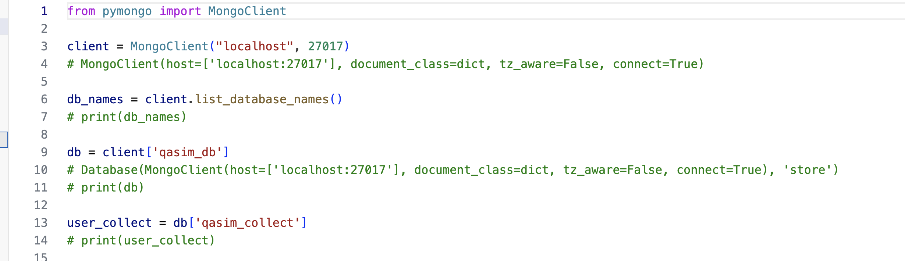
2. Insert User - Qasim, Dinakar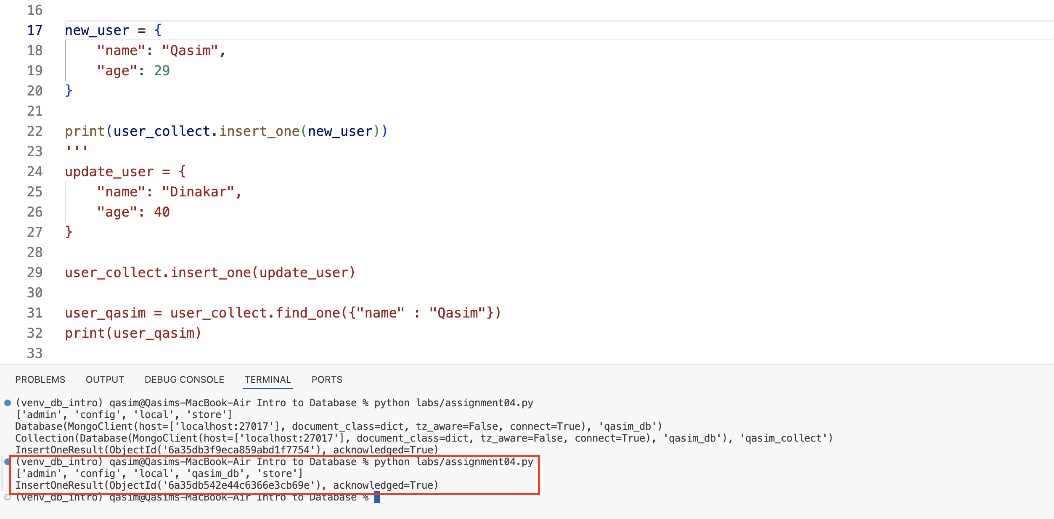
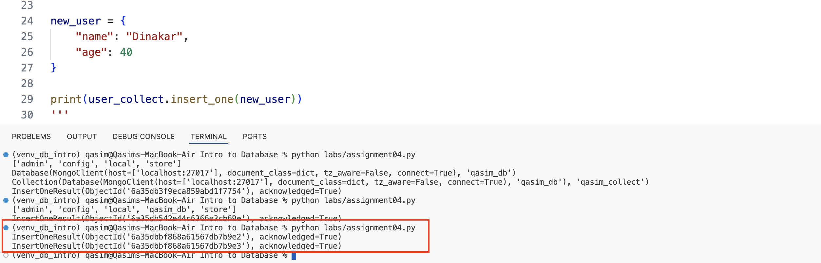

3. Insert User - Sherzod
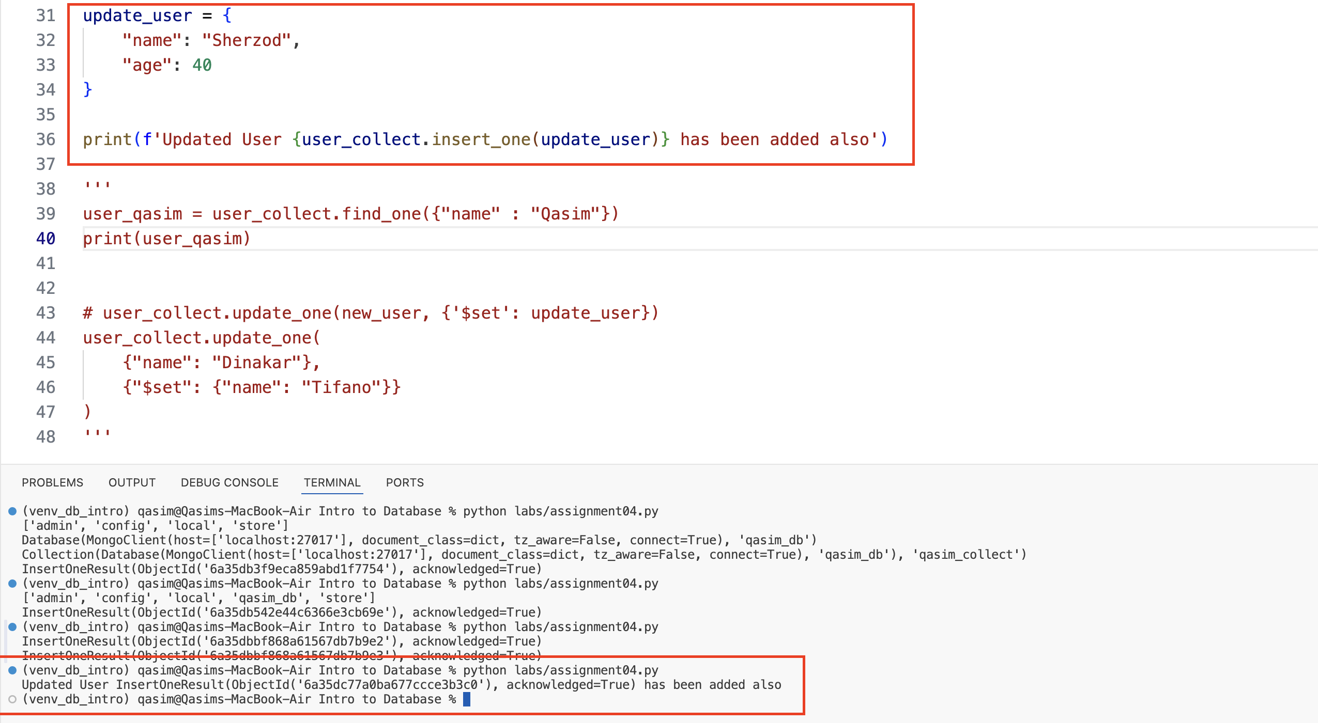
Three documents exist in the database as of now:
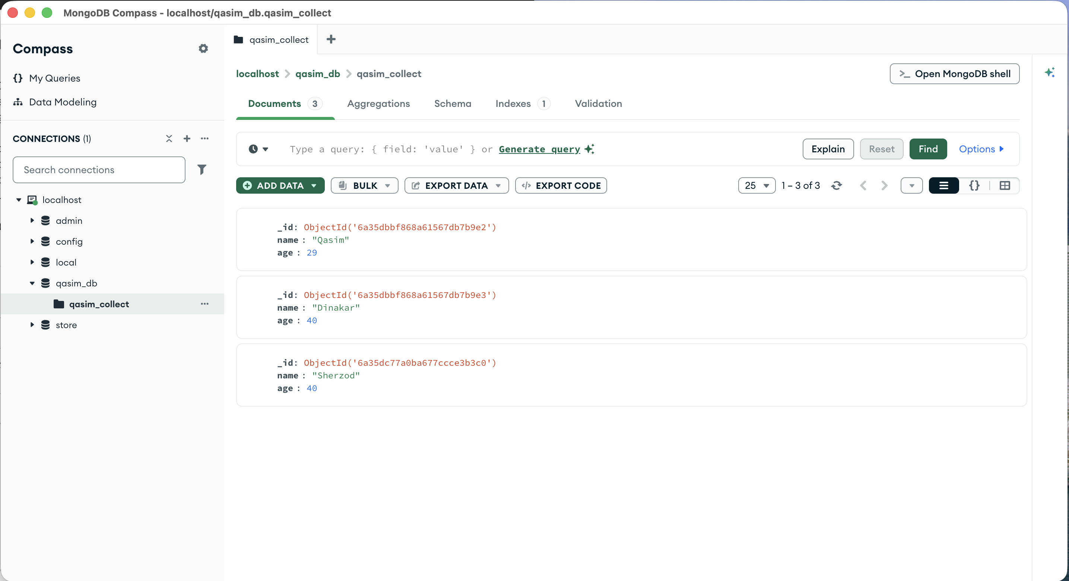

4. Find User – Qasim
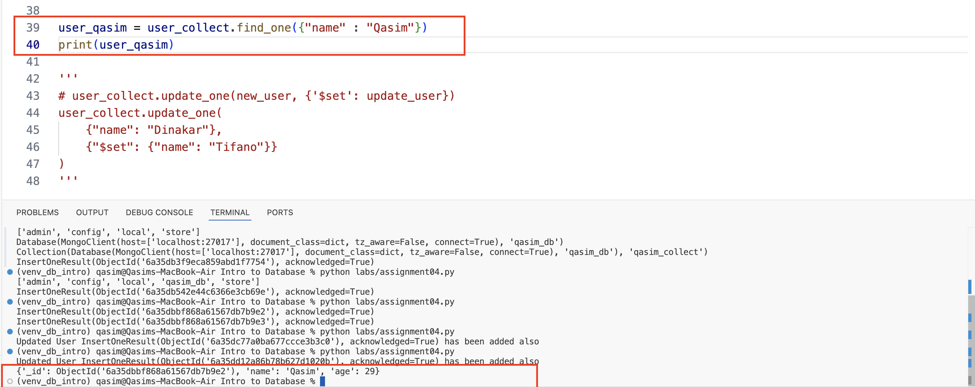
5. Update User Dinakar with Tifano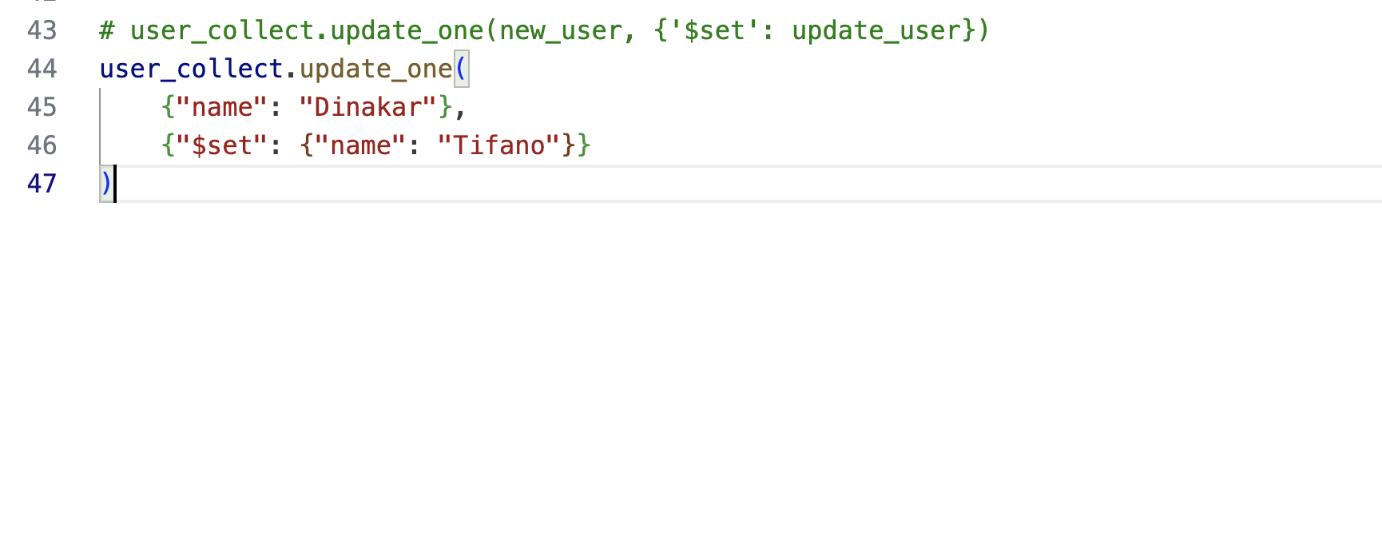
User has been updated
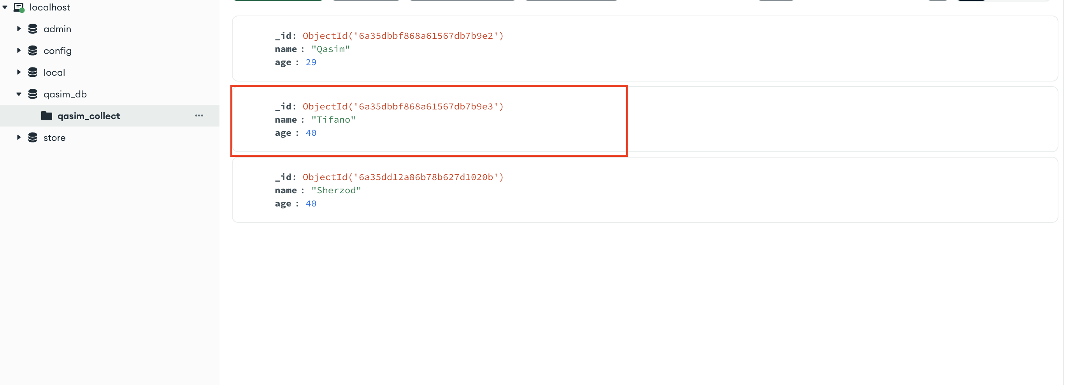
6. Delete User – Tifano

User has been deleted
